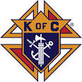
Special Camps + The Knights of Columbus

Present

A Free Easter Event At The DuPage County Fair!

Dear Special Families + Friends,

Families of those with intellectual disabilities and autism (kids and adults), are invited to join us for this FREE event! Come and enjoy in on a host of fun activities designed for the entire family.

The Knights will provide a nice luncheon with burgers, brats and a taco bar. Please feel free to pack a sack lunch or special utensils for any family member who may need an alternative meal. A microwave / fridge will be available for you.

Place: The DuPage County Fairgrounds Sunday, March 12th
2015 Manchester Road, Wheaton, IL 12 - 3 pm

Easter Egg Hunt with the Easter bunny Luncheon Crafts Hayrides

Karaoke Face Painting Petting Zoo Games

Directions: The DuPage County Fairground is located off of County Farm Road between Roosevelt road and Geneva Roads in Wheaton. There will be two different events held that day. Please look for the Easter party signs to guide you to the Easter Party parking lot.

Hosted by: Special Camps and the Knights of Warrenville, Wheaton and Winfield.
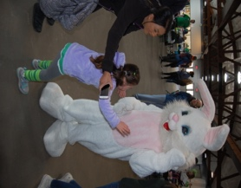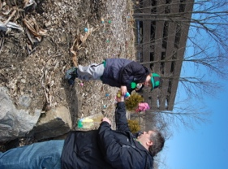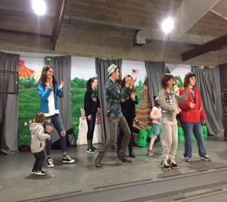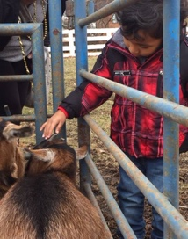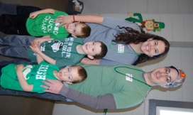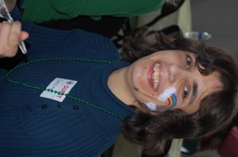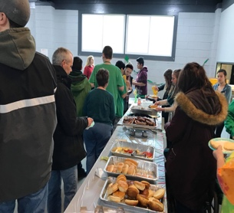

Please Reserve Your Spot by March 1st with # of special guests + family / aides attending to Kevin (630) 235-6456 or dd.kevin.callahan@gmail.com. Please follow the Easter signs to the event parking lot.

Thank you and… Happy Easter!

